

Formal comment to Request for Information (RFI) Related to NIST's Assignments Under Sections 4.1, 4.5 and 11 of the Executive Order Concerning Artificial Intelligence (Sections 4.1, 4.5, and 11)

Imatag’s comments

Date: 02/02/2024

Authors from Imatag: Mathieu Desoubeaux - Anthony Level - Thierry Secretan - Vivien Chappelier - Christine Deschaseaux - Teddy Furon

_________________________________

Imatag wishes to submit a formal comment through NIST's Request for Information to advance the measurement and practice of AI safety and trust, help NIST to identify the most robust and secure solutions on the market, and share its 10 years of experience in digital watermarking. Imatag’s team hopes its contribution will help NIST to develop guidelines, standards and best practices for AI safety and security.

Our team remains at your disposal for any further information you may require or any demonstration of the robustness and security of our technologies.

**Summary**

**Imatag presentation 3**

**Preliminary note 4**

**General context 4**

**Overview of main private initiatives to authenticate genuine content 6**

**Imatag’s own initiative for identifying and labeling genuine pictures on search engines 7**

**Understanding the Security Risks in Digital Watermarking 10**

**Watermarking AI-Generated Images 14**

**Conclusion 16**

**Appendix A 17**

# Imatag presentation

Imatag is a French company, spin-off from [INRIA](https://www.inria.fr/en) (renowned French institute in computer science and shareholder of Imatag), based in Rennes, France, and created in 2015. Imatag is a recognized expert in digital watermarking technology and its applications across various industries, such as press image tracking, protection of IP, and sensitive visual content, which offers unique solutions in digital watermarking and visual recognition technology.

Built on several worldwide patents, including those of INRIA, Imatag provides a unique, invisible, and indestructible watermark that permanently associates metadata to content.

By design, Imatag’s invisible watermark embeds a hidden signal that cannot be reverse-engineered and is still detected after compression, cropping, scaling, screenshots, colorimetry modification, and/or other alterations. Imatag’s reverse image search engine can reach 100.000.000 images per day and recognizes content even if modified/altered.

Imatag solutions have been used for years, particularly by global press agencies such as AFP (Agence France Presse).

At a time when the digital world is filling up with content generated by artificial intelligence, it's becoming urgent to identify real and authentic content. Imatag's solutions allow certifying that a piece of content is real or produced by humans. In addition, Imatag’s solutions provide trusted and immediate knowledge through visualization of the original content, associated metadata, source, and context, whether and how real content (photo, video…) has been manipulated or falsely attributed.

Some of the world top news agencies, leaders in consumer electronics and leaders in the automotive industry have already chosen Imatag’s watermarking solutions, one of the strongest and most secure existing in the market.

Imatag is a [C2PA](https://c2pa.org/) member.

Website: <https://www.imatag.com/>

# Preliminary note

Given Imatag's area of ​​expertise, this contribution primarily concerns the authentication of genuine content (photo, video), authentication of AI-generated content, and the risks linked to the use of generative AI with regard to the reliability of information and the integrity of the information sphere.

Moreover, Imatag has recently undertaken significant initiatives in AI-generated watermarking techniques (see Appendix A).

Our comment is focused on “watermarking”, specifically addressing the following topics :

* Risks and potential harms of generative AI (deepfakes & fakenews)
* Content authentication, provenance tracking, and synthetic content labeling and detection
* Security implications of watermarking, provenance tracking and other content authentication tools

# General context

*Addressing excerpt:*

|  |
| --- |
| * Risks and harms of generative AI |

The advent of generative AI entails a major risk of seeing reliable publishers drowned in an ocean of increasingly realistic false information, a risk described as “infocalypse”.

The temporal conjunction between the dazzling progress of ultra-realistic generative AI (for example, version 6 of Midjourney - see illustration below) and the holding of major elections in the USA and Europe in a context of latent or declared wars generate in 2024 a paroxysm of disinformation. Indeed, the accessibility and ease of use of generative AI significantly lowers the barrier to entry for disinformation campaigns.

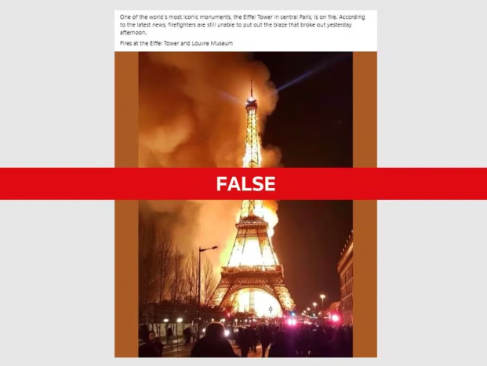

*Above is an image generated with Midjourney v6, where the Eiffel Tower is represented on fire. This deepfake has been [debunked by Reuters Fact Check](https://www.reuters.com/fact-check/fake-photo-shows-eiffel-tower-ablaze-2024-01-18/)*

There is no doubt that among the most dangerous deepfakes are, for example, those deployed just before elections so that their “debunking” cannot be carried out on time, leaving doubt in the minds of voters when voting. There is, therefore, a problem of immediacy in knowing whether the information is true or fake.

The need to authenticate real content is shared by Yann Lecun in this [tweet](https://twitter.com/ylecun/status/1749793532054004144?s=46&t=Kys4ZwfLc4ce6kqvAyFCwg). Lecun is one of the pioneers of AI, currently chief AI scientist at Meta.

# Overview of main private initiatives to authenticate genuine content

*Addressing excerpt:*

|  |
| --- |
| * Content authentication, provenance tracking, and synthetic content labeling and detection |

It is interesting that private initiatives have emerged to try to re-establish elements of trust in consulting information on the Internet, but they remain sectoral, voluntary, and limited. Faced with systematic doubt regarding the veracity of content published on the Internet, the new services offered aim to allow Internet users to verify the reality of content, generally through action on their part.

Here are the examples that seem most significant, according to us, in the world in January 2024 :

[Content Credentials](https://c2pa.org/): Adobe, ARM, BBC, Intel, Microsoft, and Truepic have joined forces to launch the Coalition for Content Provenance and Authenticity (C2PA), which aims to provide a solution standard to combat false information and fraudulent content. Imatag is an active member of working groups related to watermarking developments. Imatag’s solution is 100% compatible with this framework. The principle is to develop provenance specifications for common content types and formats to enable publishers, creators, and consumers to trace the origin and evolution of a piece of media, including an image, video, audio passage or document. These specifications include the type of information associated with each type of content, how it is presented and stored, and how possible tampering can be detected. The coalition will also develop an open standard providing digital platforms a way to preserve and read the provenance of digital content, as well as its ownership claim history, and for consumers to decide whether what they read is worthy of trust. If the initiative is laudable, it is not flawless because if indeed the metadata remains intact, they remain erasable (therefore missing the technological brick that allows them to be permanently linked to the content, which Imatag’s digital watermarking allows).

[FOX “Verify” initiative](https://www.axios.com/2024/01/09/fox-corp-blockchain-platform-ai-licensing-verify): Fox corp. has publicly launched a new blockchain platform called Verify to help media companies track how their content is used online. The Verify blockchain protocol is a distributed Internet database of media content cryptographically signed to establish the origin and history of the content. A simple “drag and drop” on the proposed [interface](https://www.verify.fox/) let you know the content’s origin and whether its integrity has been respected.

# Imatag’s own initiative for identifying and labeling genuine pictures on search engines

*Addressing excerpt:*

|  |
| --- |
| * Content authentication, provenance tracking, and synthetic content labeling and detection |

[Imatag itself is in discussions with the main search engines](https://www.journaldunet.com/publishers/1527545-anthony-level-imatag/) to identify and label images from press agencies.

The labeling of content from reliable publishers requires, to be fully effective, collaboration on the part of all players in the ecosystem who distribute and display this information (search engines, social networks, sharing platforms, etc.). Once this labeling is effective, their discoverability and referencing can be improved to counter the surge of false information, as provided by the “[Journalism Trust Initiative](https://rsf.org/fr/journalism-trust-initiative)” program offered by Reporters Without Borders in partnership with Microsoft Bing.

Thus, not only does watermarking allow the public to immediately visualize whether an image is real, and obtain information on its provenance, date, author, and context, but it also makes it possible to immediately detect if and how a photo or video was created or modified.

In a single technical operation, it is possible to obtain two immediate effects that contribute to the fight against disinformation and deepfakes: the labeling of real content and at the same time the detection of potentially misused real content.

**

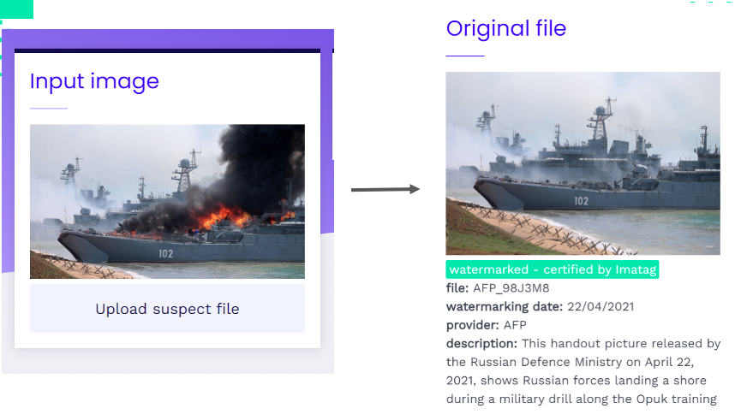

*See the example below: the image of a Russian boat on fire was uploaded to YouTube, suggesting that a large-scale attack had occurred (input image). However, in reality, the image comes from AFP and shows a Russian military exercise for which fire was artificially added using Photoshop-type software.*

Imatag technology makes it possible to visualize modifications (below in blue):



If graphic diversions of real images do take place (by addition/deletion of visual elements), in practice, a larger proportion of diversions of real images is carried out simply via the decontextualization of the real image in question (attribute an image to a particular event when it relates to another event, in time or space):

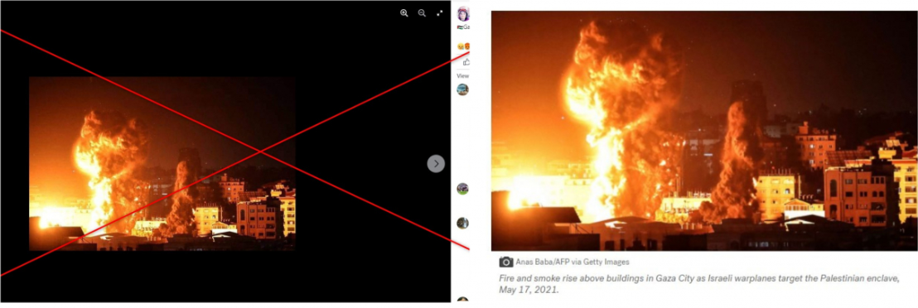

*Above, false attribution of a bombing in Gaza on New Year's Eve 2024 (left), published on Facebook, while the image (AFP) dates from 2021. By displaying the real context of origin, the false context is debunked.*

To fight against disinformation, it is easier and more effective to identify and highlight information from official or reliable publishers than to “debunk” constantly renewed fake news. Indeed, this “debunking” will prove more and more difficult in the future due to the ever-increasing realism of AI-generated content plus the fact that the latter will soon represent the vast majority of content published on the Internet.

# Understanding the Security Risks in Digital Watermarking

*Addressing excerpt:*

|  |
| --- |
| * Security implications of watermarking, provenance tracking and other content authentication tools |

The digital age has brought many innovations, and one of them is digital watermarking, a technique used to protect copyrights in digital media. This method involves embedding a unique code, or watermark, into various forms of content like images, videos, and audio to signify ownership, enable identification or authentication. Despite its widespread use, digital watermarking is not devoid of security challenges. The technology faces significant risks, primarily due to the misuse or misunderstanding of watermarking keys.

Imatag has considered these risks when building its solution.

## Robustness and Security: Two Often Confused Subjects in Watermarking

Over a decade ago, the authors of this [paper](https://www.researchgate.net/publication/229150577_On_the_Robustness_and_Security_of_Digital_Image_Watermarking) noticed a lack of emphasis on security compared to robustness in digital image watermarking research. This stems from a common misconception in the field where security is frequently conflated with robustness. However, while they share similarities, both aspects demand distinct evaluations and considerations.

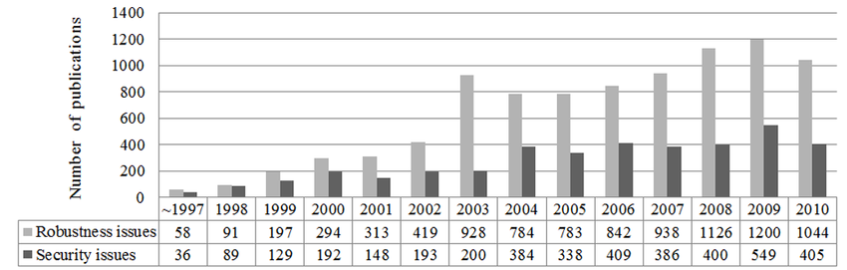

*Yearly published articles in digital image watermarking to robustness and security problems.* [*https://www.researchgate.net/publication/3319323_Watermarking_security_Theory_and_practicesee*](https://www.researchgate.net/publication/3319323_Watermarking_security_Theory_and_practicesee)

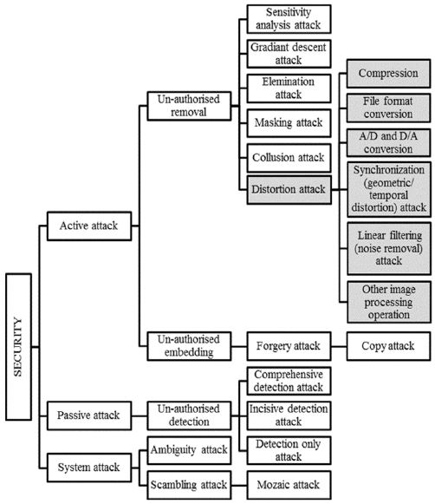

*Attacks for digital image watermarking.*

*‍*[*https://www.researchgate.net/publication/229150577_On_the_Robustness_and_Security_of_Digital_Image_Watermarking*](https://www.researchgate.net/publication/229150577_On_the_Robustness_and_Security_of_Digital_Image_Watermarking)

## Watermarking Key: The Core of Digital Watermark Security

Central to the concept of digital watermarking is the 'key' used for embedding and detecting the watermark. Much like a password, this key is fundamental to the watermark's security. However, a common misstep in watermarking is using the same key across multiple pieces of content. This practice is akin to using a single password for different online accounts, presenting a significant security risk. An attacker who decodes the key from one piece of content can potentially access or alter the watermark in others. Therefore, the security of a watermark heavily depends on its key’s uniqueness and secrecy.

## ‍Theoretical Insights into Watermarking Security

Nearly two decades ago, researchers like [Teddy Furon](https://scholar.google.fr/citations?user=aLUbWzAAAAAJ&hl=fr) from Imatag offered profound insights into the [security of digital watermarking](https://core.ac.uk/download/pdf/51220462.pdf). They approached the topic using information theory, a branch of applied mathematics and electrical engineering involving the quantification of information. In particular, they utilized concepts like Shannon's mutual information and the Fisher information matrix to measure how much information about a key could be leaked through watermarked content. These mathematical tools helped quantify the vulnerability of watermarking systems, offering a theoretical framework to understand and improve their security.

## ‍Common Watermarking Techniques and Their Vulnerabilities

Two prevalent watermarking techniques are the substitute scheme and the spread-spectrum technique. The substitute scheme involves altering certain bits in the content, while the spread-spectrum technique disperses the watermark across the host signal. Though effective, these techniques have vulnerabilities. For instance, if the same key is used across various contents, it becomes easier for attackers to identify and manipulate the watermark.

## ‍Blind Source Separation: A Threat to Watermark Security

One advanced method that poses a threat to watermark security is blind source separation. This technique allows attackers to separate the watermark from the content without knowing the key. By analyzing the differences between watermarked and non-watermarked content, attackers can effectively 'crack' the watermark, rendering it useless for its intended purpose.

## ‍Generative AI Watermarking: Security Still Overlooked

In generative AI, watermarking is divided into post-hoc methods (like DCT-DWT in Python’s “[invisible-watermark](https://pypi.org/project/invisible-watermark/)” and StegaStamp) and generation-based methods (like [StableSignature](https://github.com/facebookresearch/stable_signature) and [Tree-ring](https://github.com/YuxinWenRick/tree-ring-watermark) (<https://github.com/YuxinWenRick/tree-ring-watermark>) for diffusion models). Both use invisible watermarking, and while [robustness is being tested](https://wavesbench.github.io/), security is still overlooked. Current AI-watermarking uses a static message, making it vulnerable to cracking. Effective security, however, demands a variable message to prevent easy detection and manipulation.

## ‍The Role of Secret Keys in Watermarking Security

In a recent article, “[Release the Detector!](https://imatag-lab.medium.com/release-the-detector-92e6807177ff)", Imatag-Lab highlights the security aspects of watermarking technology in the context of generative AI. It points out that most current watermarking systems are symmetric, requiring the same secret key for both watermark embedding and detection. This symmetric nature presents risks, especially when the watermark embedder is released, allowing anyone to watermark content and potentially claim it as generated. Moreover, releasing the full detector enables the extraction of any watermark from content. This emphasizes the importance of secret keys for security and highlights the limitations of fixed key systems.

‍The conclusions drawn from early research on watermarking security remain valid today. Despite its nearly 20-year history, the mathematical foundation of these findings is unshaken. However, as digital watermarking becomes increasingly crucial, especially for marking AI-generated images, many users continue to misuse watermarks by not implementing the renewal of keys or by not using a unique key for each watermark. This practice undermines the technology's potential effectiveness. Properly implemented, with unique keys for each application, digital watermarking stands as a robust method of protecting digital content. The need for awareness and education in this field is paramount to prevent the undermining of an otherwise secure technology.

# Watermarking AI-Generated Images

*Addressing excerpt:*

|  |
| --- |
| * Content authentication, provenance tracking, and synthetic content labeling and detection |

As the capabilities of generative AI improve, most detectors of generated content are doomed to fail. Indeed, the objective on which generative AI is trained is to mimic the distribution of real content. Therefore, the artifacts on which most detectors rely are fading away as new AI methods are designed. This was recently illustrated when OpenAI removed its own Chat-GPT detector due to its [poor performance](https://www.businessinsider.com/openai-chatgpt-ai-detection-tool-shut-down-over-inaccuracy-2023-7?r=US&IR=T).

Within AI, watermarking involves adding machine recognizable patterns to digital content (such as images), where these patterns convey information such as where the content came from and whether it’s synthetic. By proactively adding watermarks to digital content as it’s created, it becomes possible for people and platforms to detect and track digital content as soon as it is shared. New approaches to watermarking, such as those pioneered by Imatag, create watermarks that are imperceptible to humans but can be recognized by algorithms, so as not to disrupt usage of the content. New digital watermarking methods are also designed to be robust to common alterations (e.g. compression, cropping, and color changes in the case of images).. AI watermarking solutions are secure if malicious attempts to remove, extract, or forge watermarks cannot be done by a third-party unaware of the secret used to protect the solution.

This compromise between imperceptibility, robustness, and security is key to evaluating watermarking systems. As it spreads on the Internet, digital content is often modified multiple times for technical or editorial reasons. For example, it may be recompressed to save bandwidth or cut to optimize rendering on various devices. [Current open-source watermarking solutions](https://medium.com/@steinsfu/stable-diffusion-the-invisible-watermark-in-generated-images-2d68e2ab1241) [are not robust enough to these kinds of alterations for practical use](https://www.wired.com/story/artificial-intelligence-watermarking-issues/).

Two distinct methods are currently being studied for watermarking AI-generated images. The first method involves watermarking the output of the generative AI model after it’s created, just as it can be done with real content. In this context, providing a digital watermarking solution that is fast, robust and absolutely secure is possible, as was demonstrated by Imatag who is delivering such a system for some of the biggest [newswires](https://www.prnewswire.com/news-releases/afp-selects-imatag-to-track-the-uses-of-its-photographs-301550539.html) on real images. Current closed systems like DeepMind with SynthID, already include watermarking algorithms in their generative [processes](https://deepmind.google/technologies/synthid/), but applying watermarks as a post-process in an open system has the strong drawback that it is easily removed by simply commenting out a line of code.

The second method implements the watermarking process during the creation of AI content, which is possible for anyone to apply to open-source AI models like those made available on the Hugging Face platform. Given the impracticality of relying on the community to apply watermarks after image generation, it is essential to distribute AI models already modified to automatically embed watermarks as part of their generation process. This is the reason why Hugging Face has been collaborating with Imatag to provide invisible watermarking for the generative AI community — as we explain in Appendix A —, and why Imatag has been prioritizing watermarking methods that do not alter the quality of model output, while also keeping high watermarking robustness and security levels.

To address the problem of scalability, watermark detection algorithms must be extremely reliable and designed to operate at a very low false positive rate. Indeed, with the number of AI generated images reaching [15B/year](https://journal.everypixel.com/ai-image-statistics), one cannot rely on detectors operating at even 0.1% error rate —as studied in the very recent [WAVES benchmark](https://wavesbench.github.io/) — which would mean accepting 15M images per year incorrectly identified as human-made! IMATAG’s solution within HuggingFace focuses on providing certified and calibrated detection probabilities to ensure these requirements are met.

# Conclusion

Current solutions deployed to watermark AI generated content are not matching any requirement in terms of security level. A minimum technical barrier should be to “keep honest people honest” and ensure state of the art technical security measures.

In a closed system, a robust and secure watermarking for real content or generative AI is possible as demonstrated by Imatag. Such a system could be implemented today by the main generative AI providers where the risk to produce AI content indistinguishable from real content is maximal. Compared to the cost of training those models, the cost of this additional security measure would be marginal.

For open systems, ensuring the security of watermarks is still an unsolved problem. Nevertheless, adding robust watermarks during the generative process is essential to help AI content detectors stay competitive for most threats.

# Appendix A

## Imatag's Watermark for AI-Generated Images - Imatag's "Watermarked SDXL-Turbo Demo" on Hugging Face

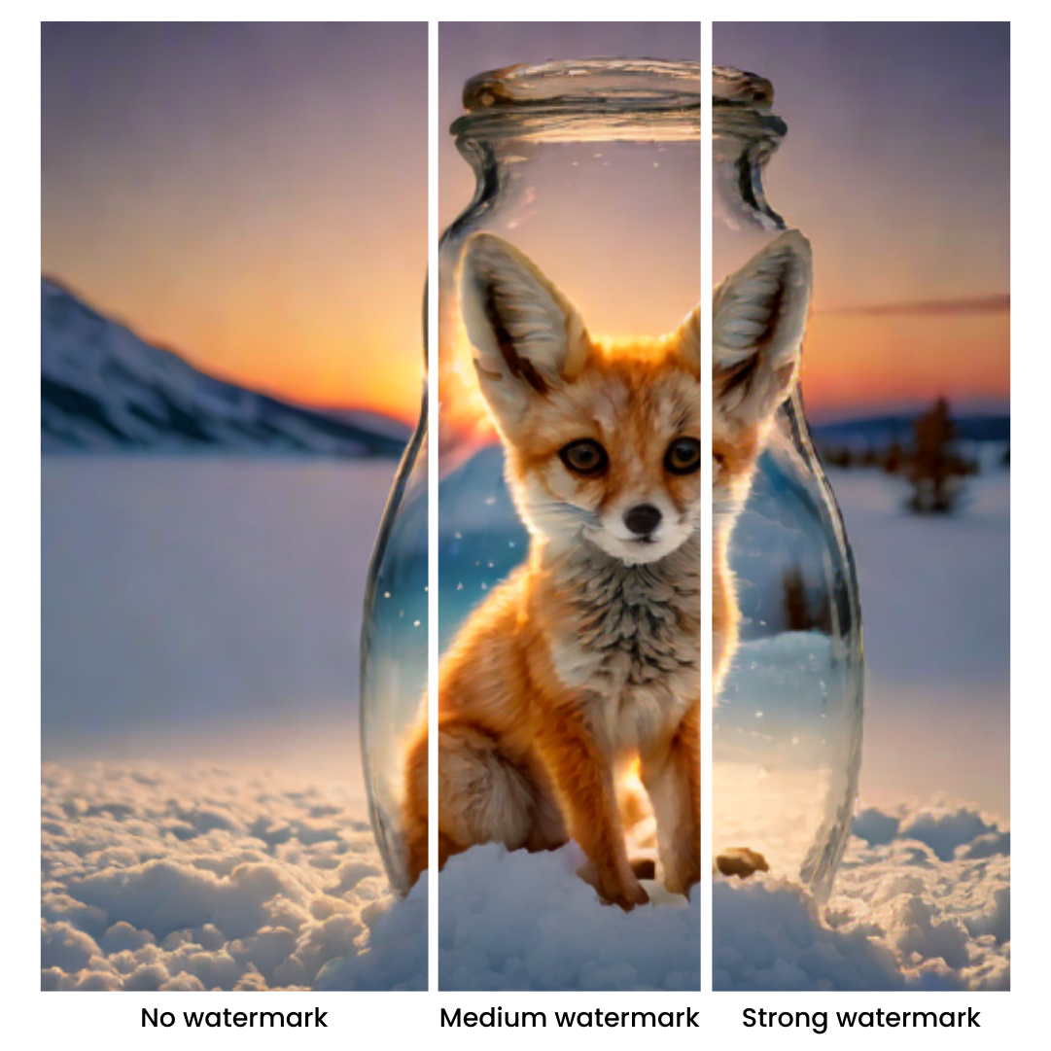

*Imatag embeds an imperceptible digital watermark in the AI-generated image*

‍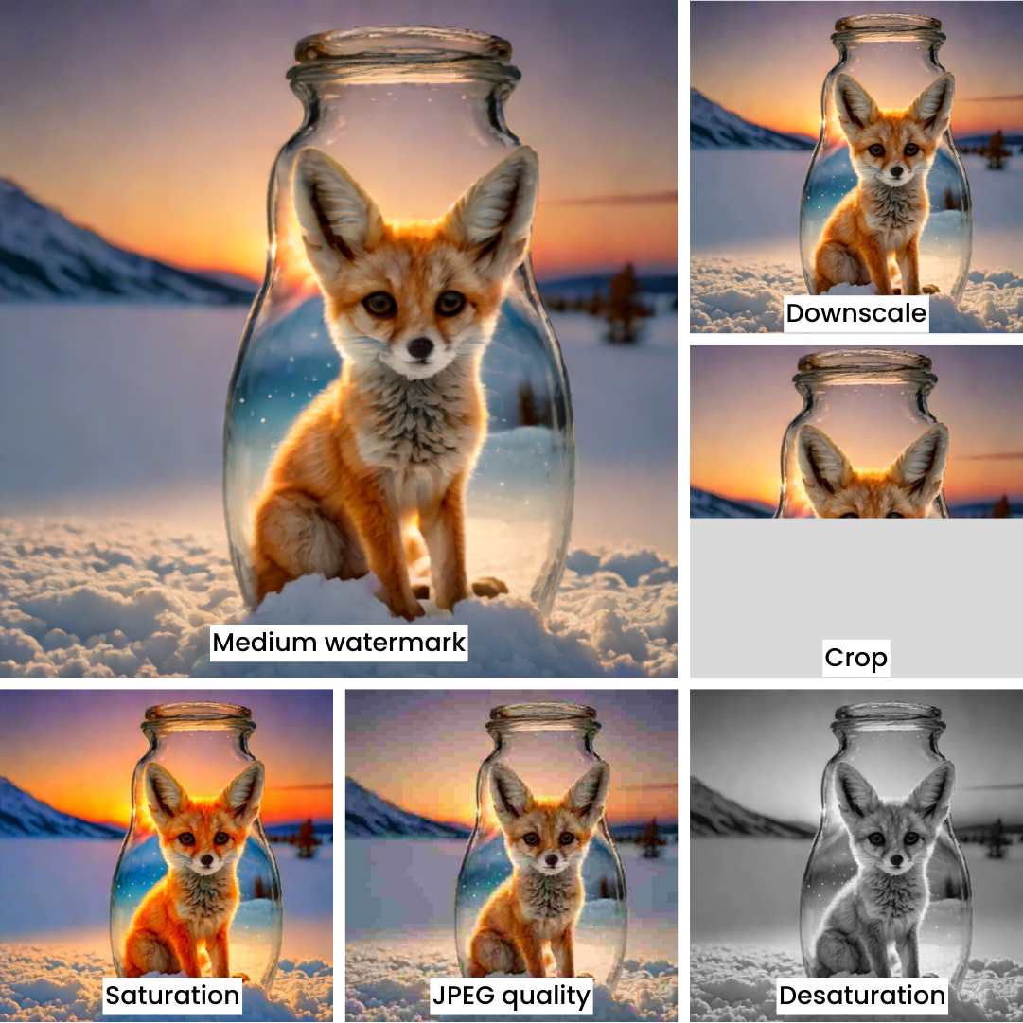

*The watermark is detectable even after modifications like cropping, changing saturation and compression.*

On November 28, 2023, [Stable Diffusion released SDXL Turbo](https://stability.ai/news/stability-ai-sdxl-turbo), an advanced AI image generation model. Just two days later, IMATAG experts made available an invisible watermarking solution on Hugging Face to identify images generated by this AI.

In this demo, users can generate an image by providing a prompt describing the desired image. An imperceptible watermark is inserted during the image generation process, certifying it as synthetic. The demo also allows for watermark detection (in the form of a probability) after subjecting the generated image to various attacks, such as compression or recolorization.

This technique is based on the refinement of a process developed by scientists at INRIA and Meta, known as [StableSignature](https://ai.meta.com/blog/stable-signature-watermarking-generative-ai/). It involves modifying the weights of the generative AI model (in this case, SDXL Turbo) to make it naturally generate watermarked images. This approach is ideal for open-source generative AI, unlike the "generate-then-watermark" techniques. For enhanced robustness, Imatag combined this method with its in-house zero-bit decoder (indicating the presence or absence of a watermark, without payload), capable of decoding even highly altered watermarks.

To explore the potential of this technique, [you can test it on Hugging Face](https://huggingface.co/spaces/imatag/stable-signature-bzh), adjusting parameters to control watermark visibility and robustness.

Visibility Impact: The training process balances watermark robustness and image quality. The perceptibility goal aligns with the original objective of Stable Diffusion, trained on real images.

Robustness: The demo allows you to adjust the watermark strength in the generated model, testing various trade-offs between perceptibility and robustness.

It's important to note that the detector used in this demo is a "degraded" version of our in-house detector. It has been trained to resist cropping, JPEG compression, and screen capture by smartphones. Challenges like image flips, extreme perspectives, rotations, and text addition were not part of the training. This exercise focuses on a single watermark (no traitor tracing), without a hidden message. The detector will only identify this specific watermark and no other. It remains possible to put additional features, such as [security keys](https://www.imatag.com/blog/understanding-the-security-risks-in-digital-watermarking), multiple watermarks, concealed messages, or increased robustness.

The primary goal of this demo is scientific advancement. In the case of Stable Diffusion, one can simply reload the non-watermarked model to generate watermark-free images, since the original weights are publicly available. Imatag aims to encourage model producers, such as StabilityAI, to watermark their models before any public weight release.

This initiative underscores Imatag's message to the open-source AI community: to seek digital watermarking experts for protection and GenAI watermarking compliance. The speedy and effective implementation of a tailored solution, as shown in the demo released just two days after the model's launch, is achievable, avoiding the typical quality loss associated with post-generation watermarking.

**‍**